Abstract
This document contains information on the Sandwell Active Spaces Trial which will see an area of undeveloped land bordering Gospel Oak Road undergoing regeneration as a proposed green space. Information on the trial can be found within this booklet and there is an opportunity for stakeholders to provide their thoughts and ideas for the end use of the land.
Active spaces trial – Gospel Oak Road
Stakeholder information on the Active Spaces Trial for Gospel Oak Road, Princes End, Tipton
V1.01
12/02/2021

Introduction
Sandwell Metropolitan Borough Council (SMBC) has secured funding through the West Midlands Combined Authority from Sport England to improve an area of land to provide an opportunity for local people to be more active, improve their wellbeing and potentially act as an area for education. It is part of a wider project being managed by the West Midlands Combined Authority which also includes public spaces in Walsall and Coventry. The area of land adjacent to Gospel Oak Road has been chosen for the Sandwell project, and stakeholder engagement is required to enable ideas about the possible future for the site to be shared.
This document provides stakeholders and interested parties with details of the site and an opportunity to share ideas for its possible development. It should be noted that additional stakeholder engagement sessions will be undertaken in the future once restrictions imposed by the COVID-19 pandemic are eased.

Site Location
The 0.65Ha site is located between the A4037 Gospel Oak Road and Ocker Hill Road in the Princes End ward of Tipton (Image 1 & 2), one of the six town areas of Sandwell. The nearest post code for the site is DY4 0DS. The shape of the site suggests that around 0.40Ha of the could be developed for practical use as a community open space. A site of this size could be described as a parklet or pocket park, although most such sites are 0.02Ha (ie tennis court).

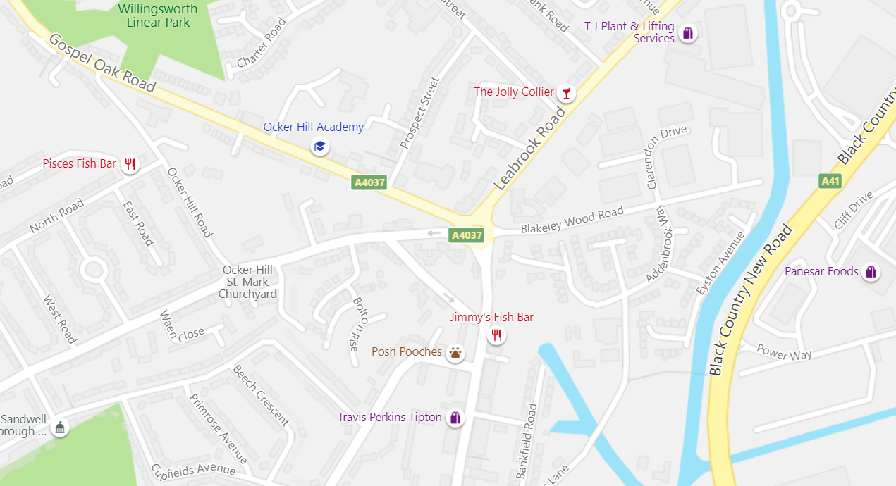
Site
Figure 1 – Street map with the site highlighted

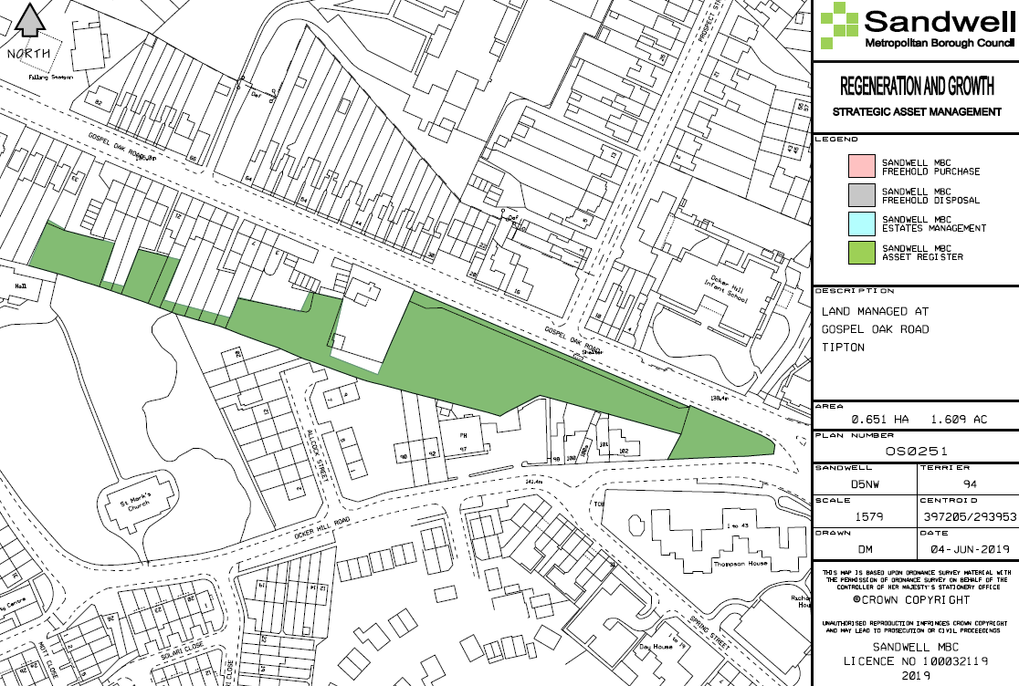
Figure 2 – View of the council owned area in its entirety, highlighted in green

Planning Matters
The site is owned by SMBC and not earmarked for housing. Part of it is designated as Community Open Space and has been used as such in the past although there is no access and the site is overgrown. Part of the site is allocated in Sandwell’s Site Allocations and Delivery Development Plan Document (SAD DPD) as a potential nature conservation site. A limited ecological survey was undertaken in 2016 which did not indicate the site being of great ecological importance.
Sandwell’s emerging updated Green Space Strategy will provide some information about how such local green spaces can be developed and how access to them can be maximised. In terms of unrestricted green space provision within Tipton, an average of 4.13Ha/1000 people is available which is slightly more than the Borough average of 3.85Ha/1000. (A national minimum is set at 2.4Ha/1000.) The area around the site, particularly in the direction of the residential area to the north west, has few such green space areas available to residents.
Local Population and Community Links
The site provides an opportunity for community and volunteering groups to be involved with the development, management and use of the site. An initial clearance of vegetation from the existing pathways and refuse dumped on the site will be coordinated through the Tipton Town Tasking group and the schools across the road from the site, Ocker Hill Nursery and Infants School and Ocker Hill Academy (Junior).

Example Proposal
The following items provide an example of what could be included in the regeneration process, supported by the available funding:
- Part of the site is fenced with gates and includes overgrown vegetation. Some of this would be cleared or tidied and would probably be informed by the ecological survey. A decision on retaining the fences and gates, and installing more for security for forestry classes
- Information boards about wildlife, species, and habitats for learning and development
- Provision of benches and cycle parking stands would be useful for promoting the site as a stopping-off point for people making cycling and walking trips past the site
- Information boards of what exists at the site/event promotion, contact details etc
- Potential for both general waste and recycling bins and dog waste bins
- A specific area allocated for mental health development and revival
- Ongoing maintenance input from various sources within the local community
- Scope for utilising any wood for the construction of benches and other items
- Volunteering groups, individuals and a new “Gospel Pocket Park” group founded to continue to maintain the area following regeneration.

Birmingham City University Student Examples
Landscape Architecture Students from Birmingham City University drafted ideas and schematics for possible uses and activities at the site along with how it could look following the site’s development. Sections of these can be seen on the following pages.
It should be noted that any decisions about activities and how the site could be formed have not yet been made and that the ideas presented here are intended to provide some initial inspiration for local people and stakeholders to develop their own ideas.

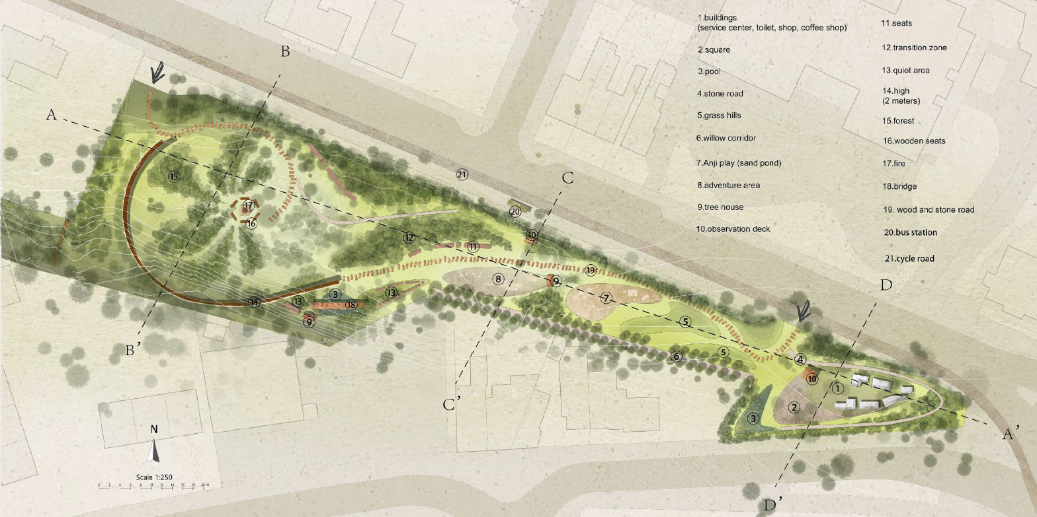
Birmingham City University Landscape Architecture students’ schematic proposal for Gospel Oak Road

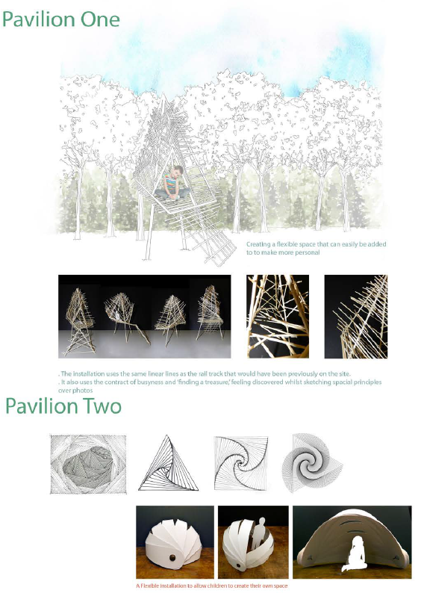
Birmingham City University Landscape Architecture students’ ideas for child friendly areas

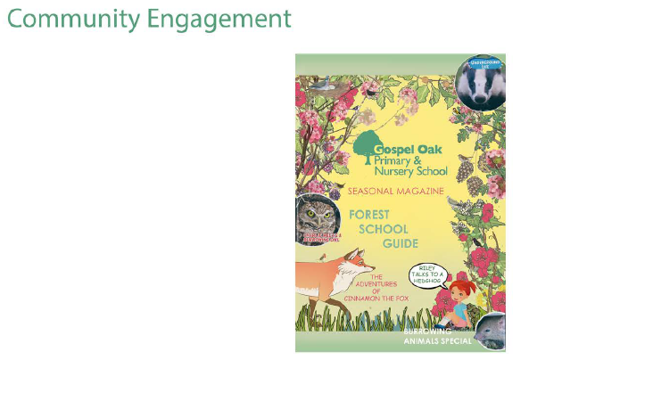
Birmingham City University student proposal for forest school lessons and outdoor education sessions

Stakeholder Engagement
This section provides an opportunity for stakeholders, interested parties and groups to provide their suggestions about how the site could be used and formed. Please write and/or draw your ideas in the space provided.

Once completed, responses can be sent to: active_spaces@sandwell.gov.uk
Any personal information will remain anonymous and responses will only used for this project.

