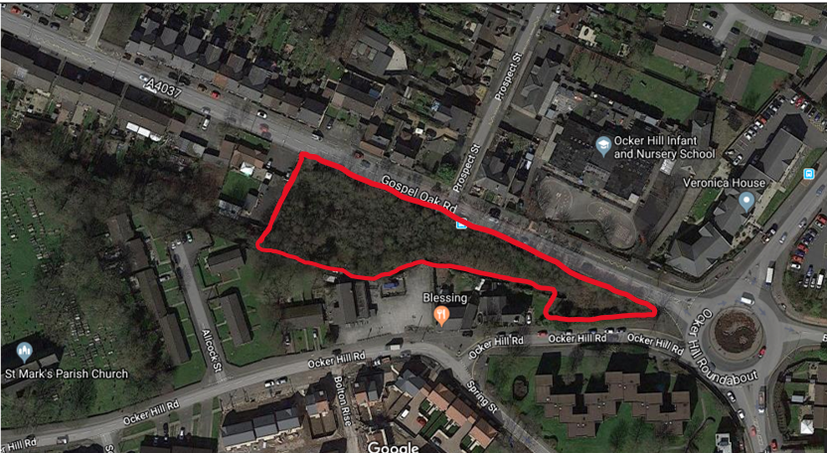

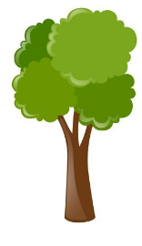

**The park has been taken over by thorns! When we have cleared them out we want your ideas on what can take their place.**

**On the next page draw or write what you want to see happen in the park.**

**Ideas like:**

* **More trees**
* **More wildlife**
* **Learning areas**
* **Forest schools**

**GOSPEL OAK PARK NEEDS YOUR HELP !**

**I want to see…**

**Your ideas can be given to your parents or teachers**



Once completed, responses can be sent to: active_spaces@sandwell.gov.uk

Any personal information will remain anonymous and responses will only used for this project.